Christopher Horyczun
February 8, 2026
Cs 2020 (Friday)
Assignment 1

Question 1:
The Auto dataset was loaded into R as a data frame. The str() function is showing us the number of observations, variables, and data types for each column. | 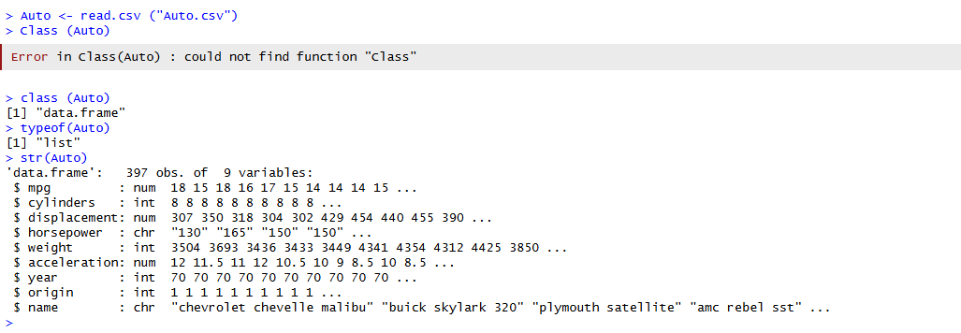

Question 2:
The dataset contains 397 obs. of 9 variables. The nrow() and ncol() functions were used to determine the size of this dataset. | 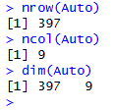

Question 3:
The dataset showed to have no missing values. After removing rows with missing values using na.omit(), the cleaned dataset contains 397 observations and 9 variables. | 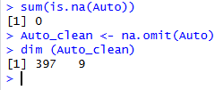

Question 4:
The names(), summary(), and head() functions were used to explore the dataset. Cylinders, origin, and name are categorical. Mpg, horsepower, and weight are continuous
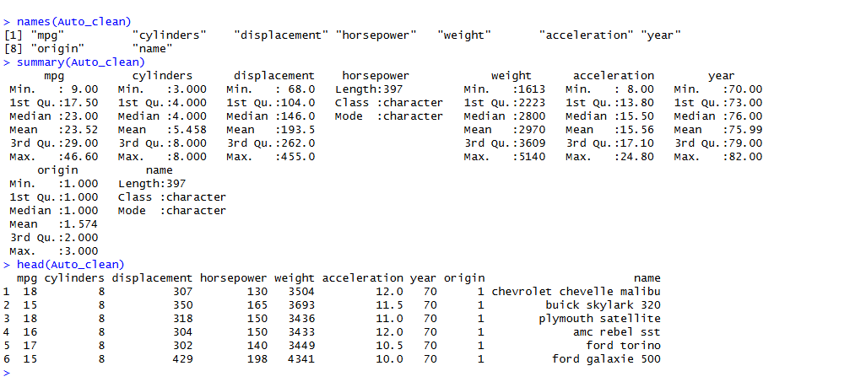

Question 5:
Two numeric vectors were created and plotted using a scatterplot. The plot shows the relationship between x and y values.
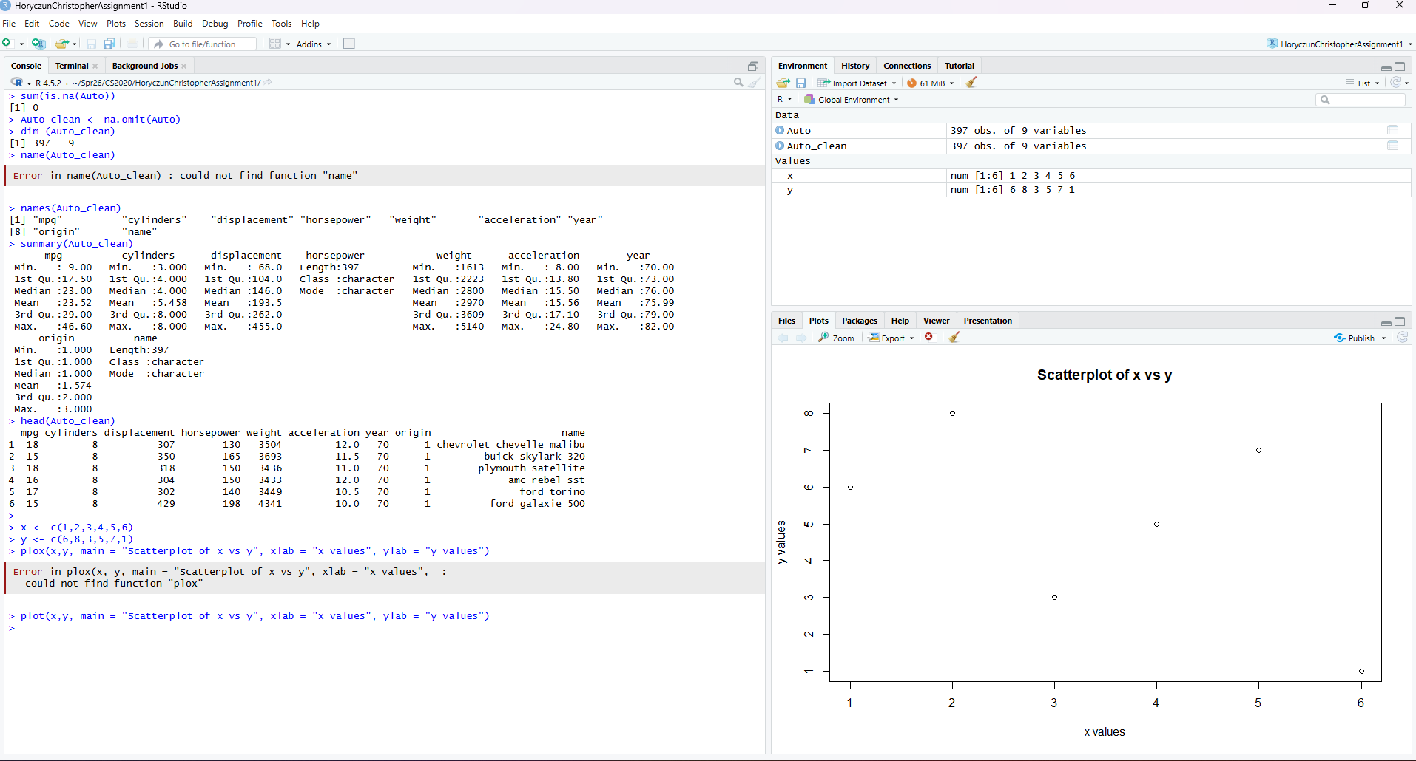

Question 6:
I converted the cylinders variable into a factor so that R would treat it as a categorical value instead of a number. After doing that, I created a boxplot to compare MPG across different cylinder counts, which shows that cars with fewer cylinders generally get better gas mileage.
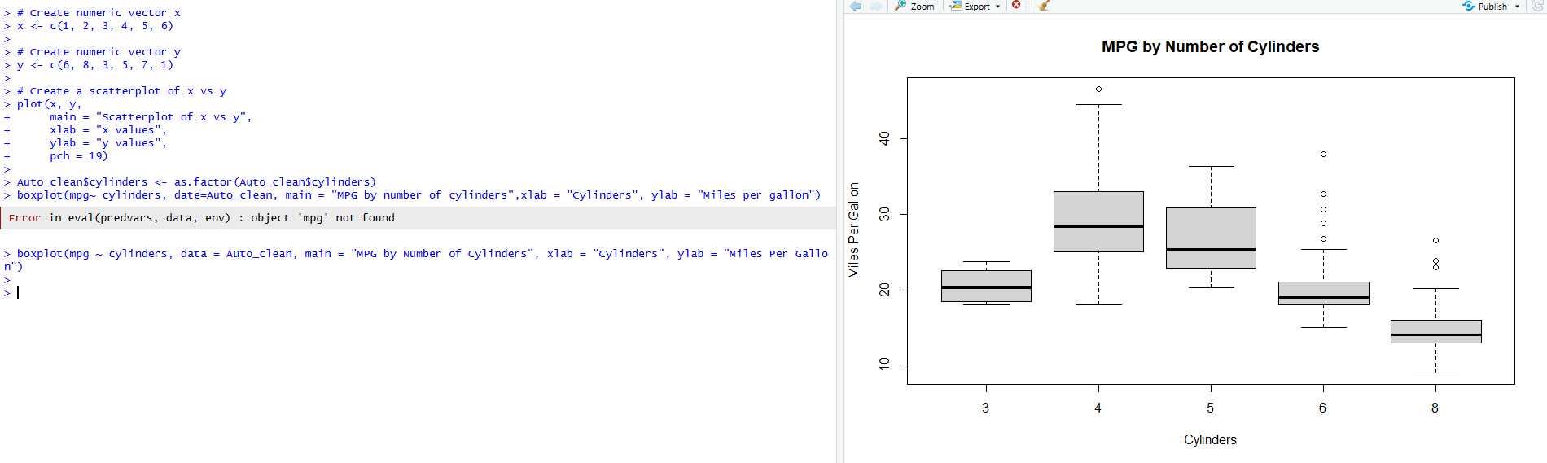

Question 7:
At first, horsepower was not stored as a numeric variable, so it had to be converted before doing calculations. After converting it, I created a new variable that represents horsepower per unit of weight to compare car performance more easily.
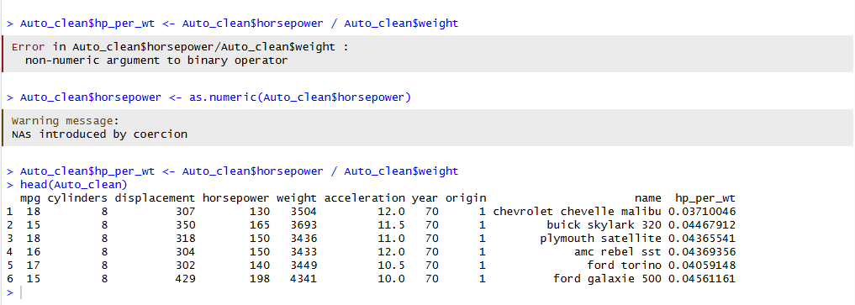

Question 8:
I created a histogram of MPG using 12 bins to visualize how fuel efficiency is distributed across the dataset. Although 12 bins were specified, some bins are not visible because there are no cars in those MPG ranges. Overall, the histogram shows that most cars fall within the middle range of MPG values.
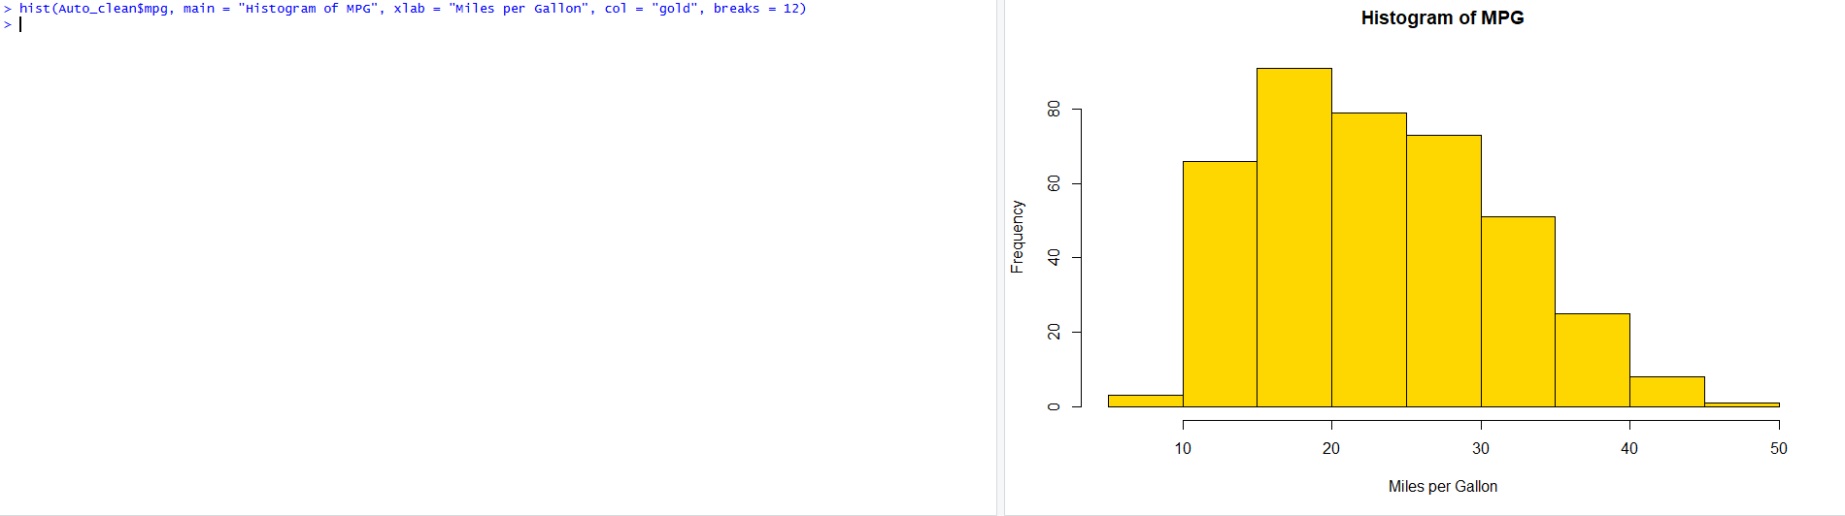

Question 9:
I used a scatterplot matrix to compare MPG, horsepower, weight, and acceleration at the same time. The plots show a strong negative relationship between MPG and weight, meaning heavier cars tend to get worse gas mileage.
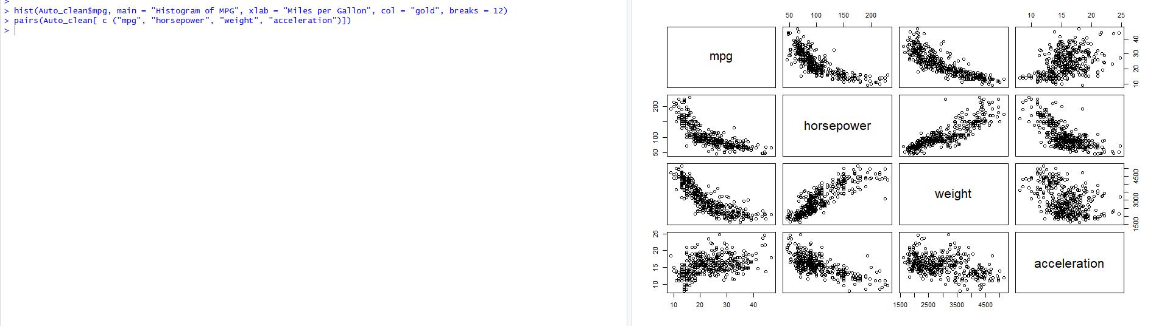

Question 10:
Following the same idea as question 6, I built a boxplot; it focused on grouping mpg by cylinders. The plot shows that cars with fewer cylinders generally have higher MPG, while cars with more cylinders tend to have lower fuel efficiency.
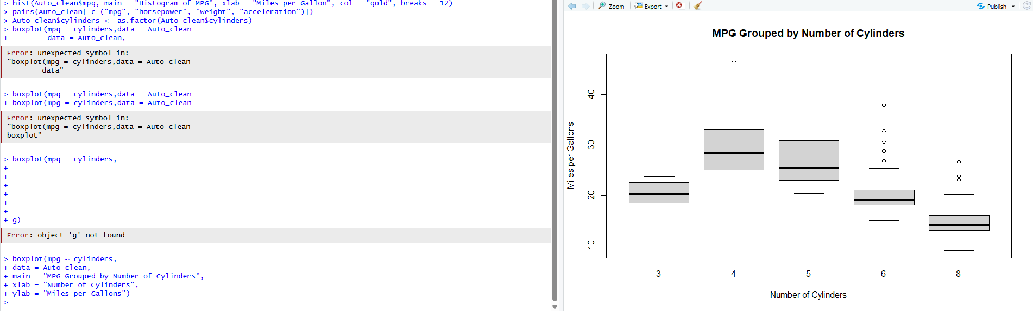

Question 11:
I saved the MPG histogram as a PNG file using the png() function. The plot was created while the file was open, and dev.off() was used to close and save the image.
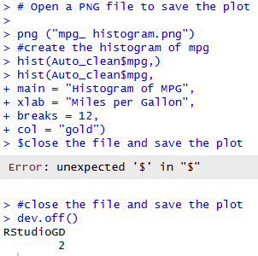 | 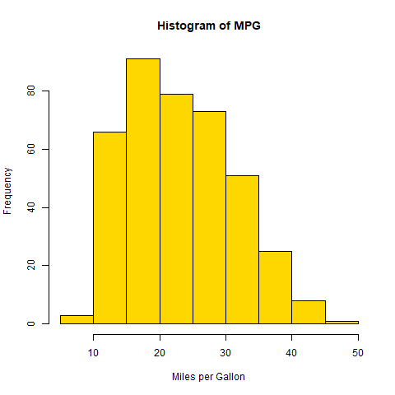

Question 12:
I created a new dataset called Auto_small that contains the first 10 observations and a few selected variables. This makes it easier to work with a smaller portion of the data. Note: I didn’t know name it right, I called it Auto_small and not small_auto
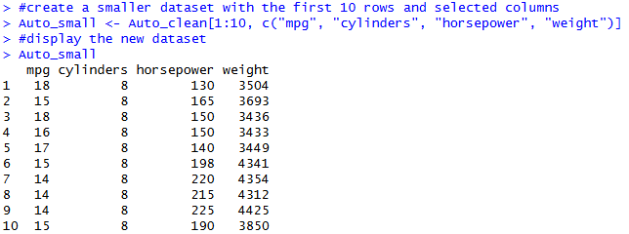 | 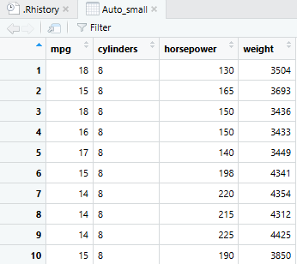

Question 13:
I used indexing to view a specific row and column from the dataset. Then, I created a new variable called efficiency that labels cars as high or low efficiency based on their MPG. | 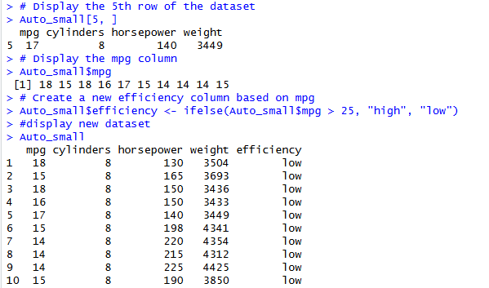

Question 14:
I sorted the dataset by MPG in descending order so that the most fuel-efficient cars appear at the top of the table. | 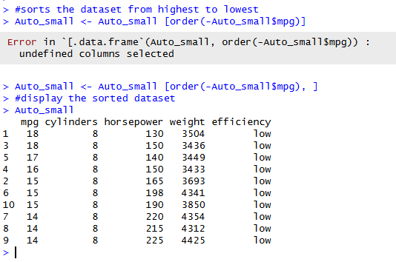

Question 15:
I used dpyr (After installing it) to complete the task in a single pipeline, but instead of using slice(); I used filter() with row_number() to select the first 10 rows. The remaining steps create a new efficiency variable and sort the data by mpg. | 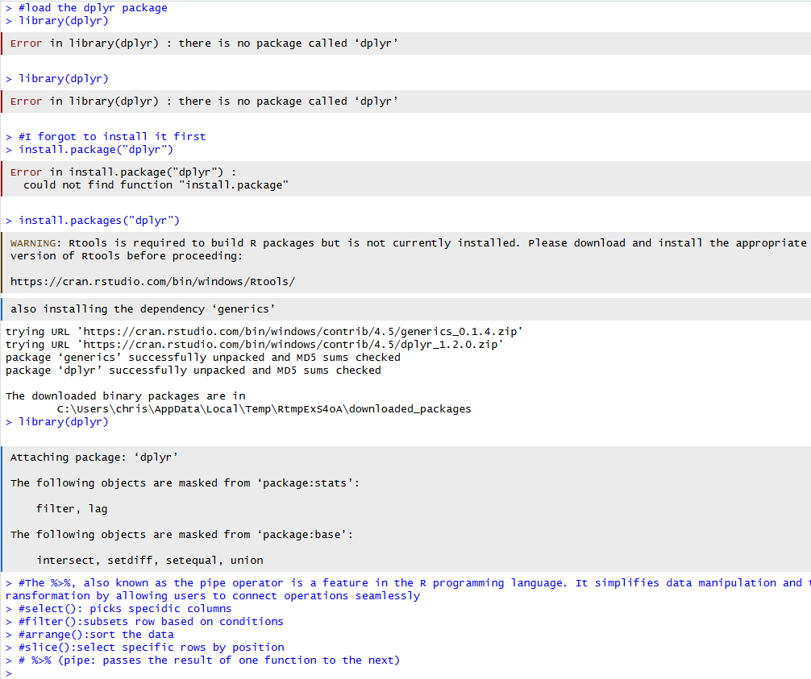
 | 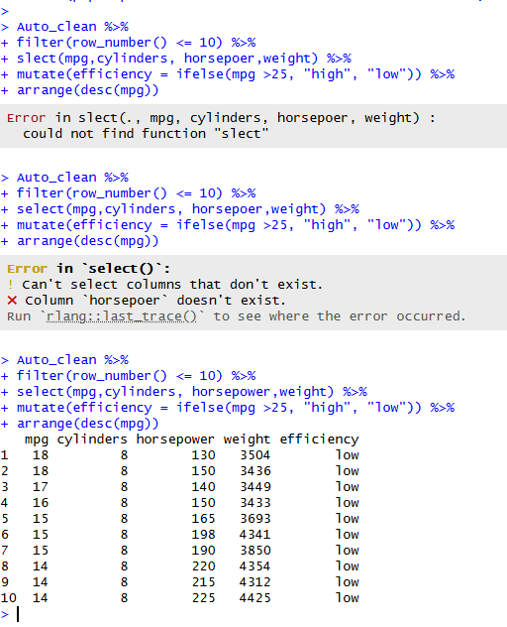

Bonus
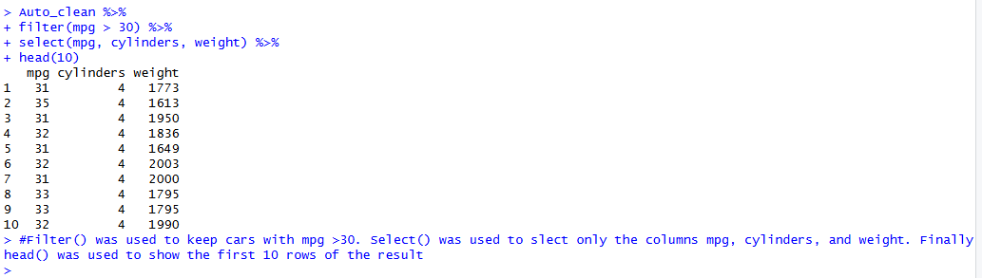
Using the dplyr concept to do the bonus question, I noticed the filter would be best fit for mpg greater than 30; select() would be best for all of steps to. Finally, I was able to head() to display the results, if I used it with 10 in the parathesis.

